1.
Create table departemen ( nodept number(2), namadept varchar2(14), lokasi varchar2(13), constraint nodept_pk primary key(nodept) );

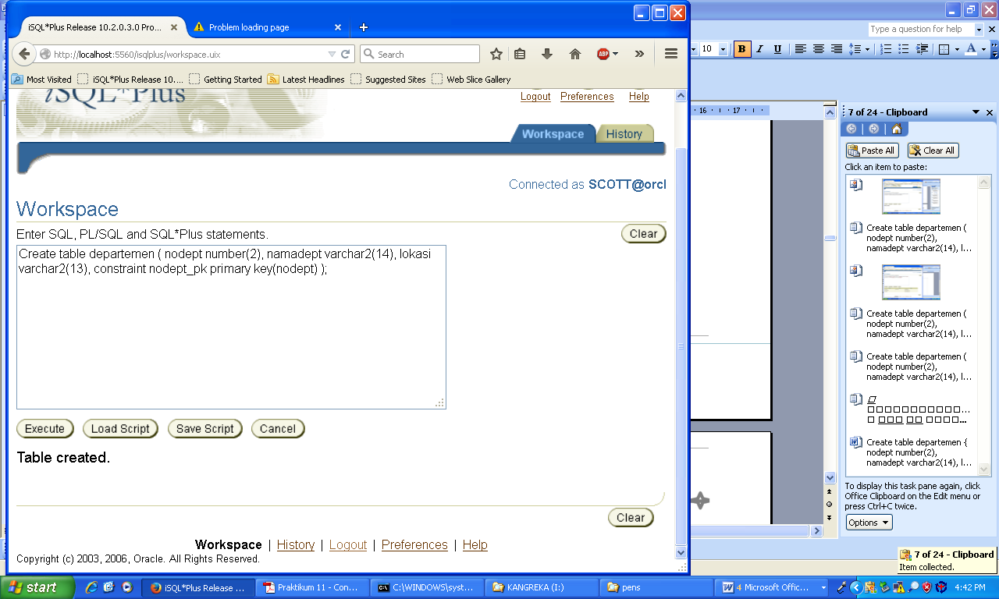

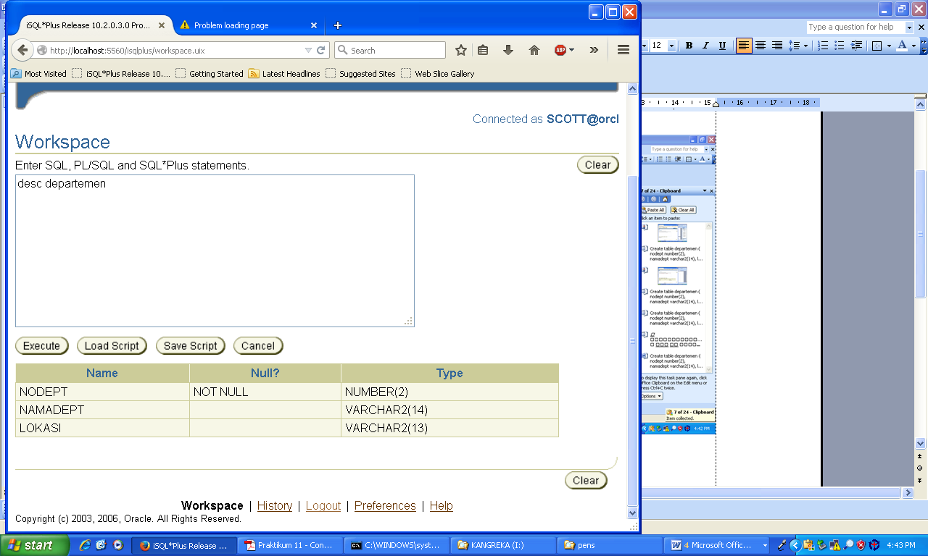

COMMENT ON COLUMN DEPARTEMEN.NODEPT IS 'Nomer departemen';
COMMENT ON COLUMN DEPARTEMEN.NAMADEPT IS 'Nama departemen';
COMMENT ON COLUMN DEPARTEMEN.LOKASI IS 'Lokasi departemen';

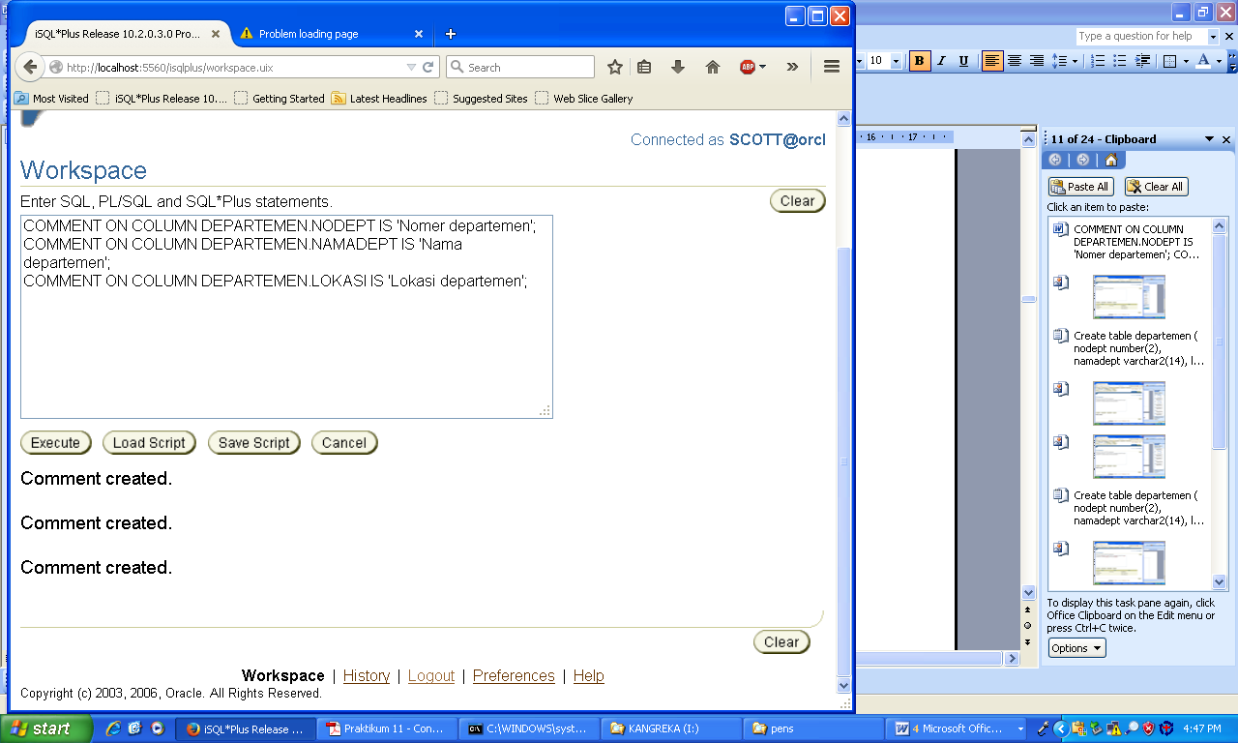

2.
Create table pegawai (
nopeg number(4), nama varchar2(10), gaji number(7,2),deptno number(2), constraint pk_nopeg primary key(nopeg),constraint gaji_ck check(gaji>0) )

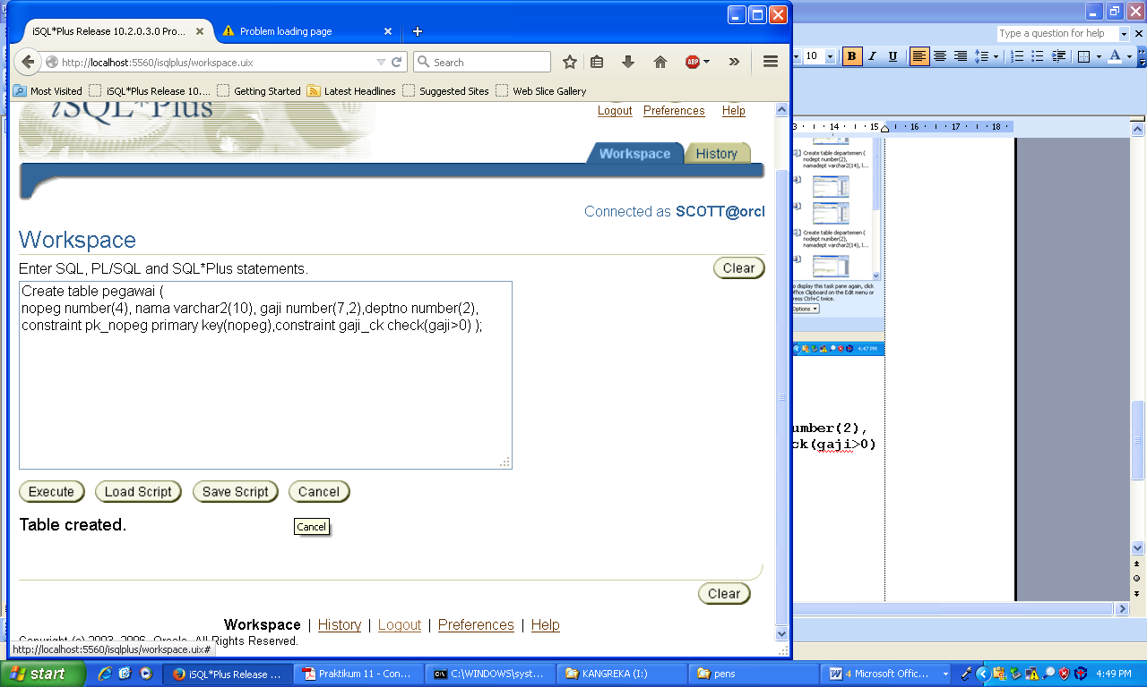

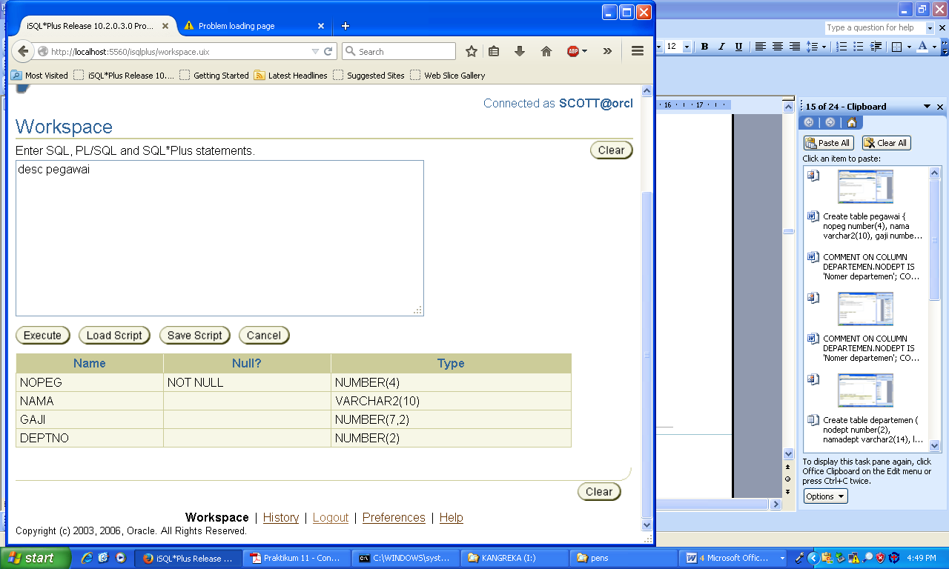

3.
Alter table departemen
add constraint namadept_uq unique(namadept)

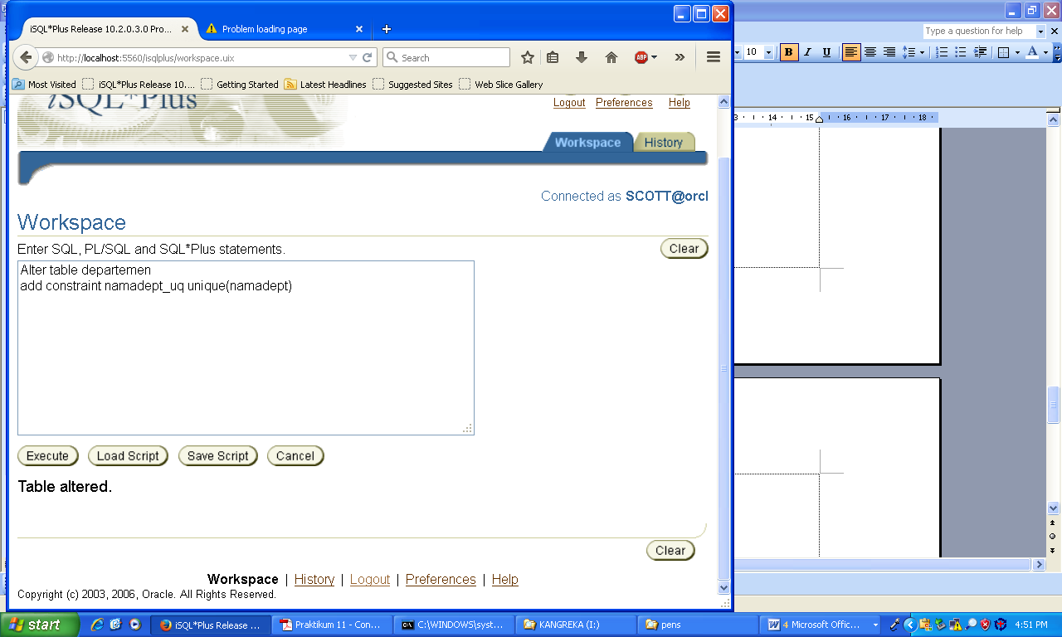
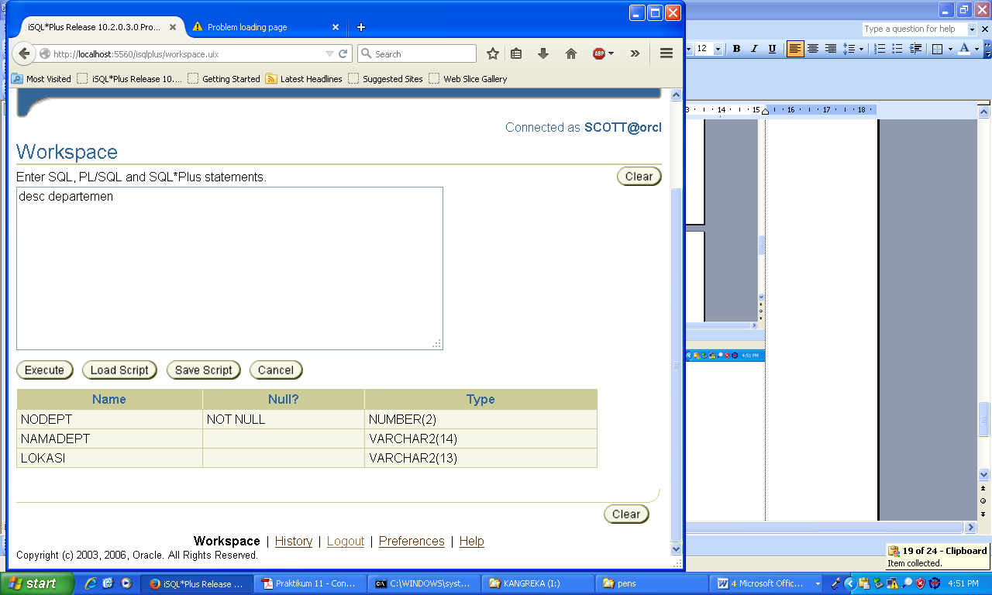

4.
Alter table pegawai
disable constraint gaji_ck

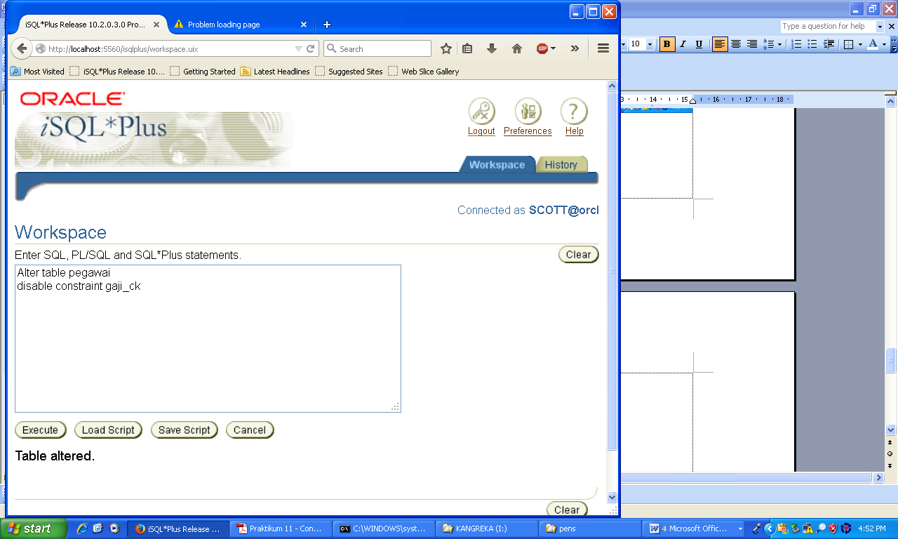
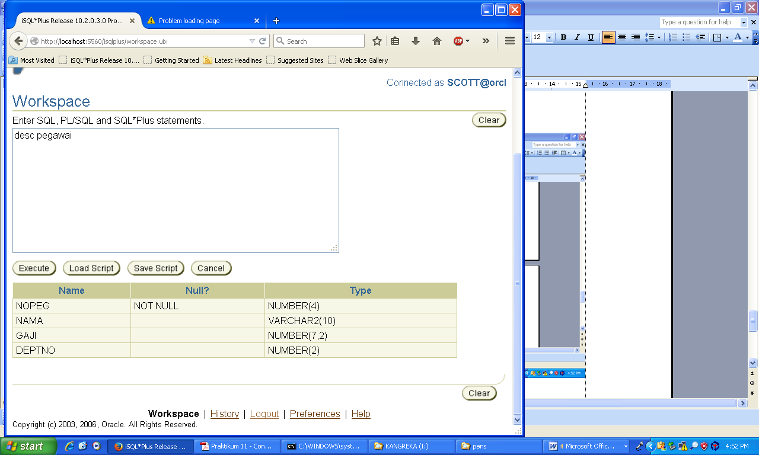

5.

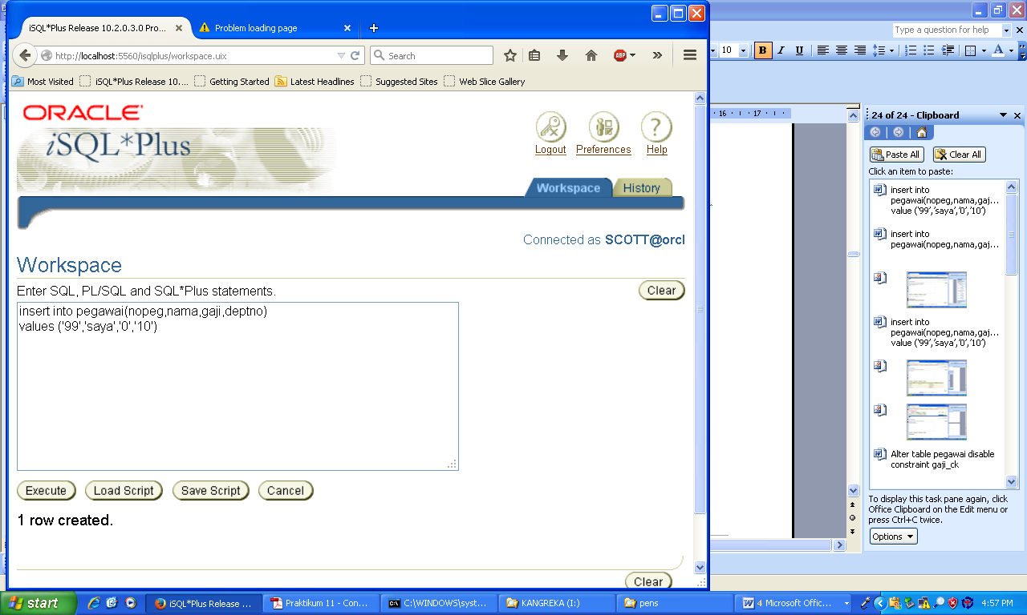

6.

